Case Study No: 1
Experiment Title: Demonstration of basics of JavaScript program.

Case Study Title: Create a webpage for college department and link the student information page with it and write a Java Script Program to Display "Welcome to SIT Nagpur" in an alert Box.

Software/ Tools Required: VS Code (text editor), HTML, CSS, JavaScript.

Case Study Program Code:
Index.html –
<!DOCTYPE html>
<html>
<head>
<title>JS 1st Practical</title>

<link rel="stylesheet" href="style.css">

<!-- Internal JavaScript -->
<script>
function showWelcome() {

// Getting values
let name = document.getElementById("name").value;
let age = document.getElementById("age").value;

// Display welcome message
document.getElementById("output").innerHTML =
"<h2>Welcome, " + name + "!</h2>" +
"<p>Your Age is: " + age + "</p>";

// Console methods
console.log("User Name: " + name);
console.log("User Age: " + age);
console.warn("This is a warning message.");
console.error("This is an error message (Demo purpose).");
}
</script>
</head>

<body>

<h1>User Information</h1>

<label>Enter Name:</label><br>
<input type="text" id="name" placeholder="Enter Name"><br><br>

<label>Enter Age:</label><br>
<input type="text" id="age" placeholder="Enter Age"><br><br>

<!-- Inline JavaScript -->
<button onclick="showWelcome(); greet();">
Submit
</button>

<hr>

<div id="output"></div>

<!-- Footer -->
<footer>
<hr>
<p style="text-align:center; color:gray; font-size:14px; margin-top:20px;">
Designed by <strong>Harman Saini</strong><br>
Roll No: <strong>24070521056</strong>
</p>
</footer>

<!-- External JavaScript -->
<script src="script.js"></script>

</body>
</html>

Script.js –

function greet() {
alert("Thank you for submitting!");
}

Style.css –

body {
font-family: Arial, sans-serif;
background-color: #f2f2f2;
text-align: center;
margin-top: 50px;
}

h1 {
color: navy;
}

label {
font-weight: bold;
}

input {
width: 220px;
padding: 8px;
margin-top: 5px;
margin-bottom: 15px;
border: 1px solid gray;
border-radius: 5px;
}

button {
background-color: royalblue;
color: white;

padding: 10px 20px;
border: none;
border-radius: 5px;
cursor: pointer;
}

button:hover {
background-color: darkblue;
}

#output {
margin-top: 20px;
padding: 15px;
background-color: white;
border: 1px solid #ccc;
width: 300px;
margin-left: auto;
margin-right: auto;
border-radius: 8px;
}

Output:
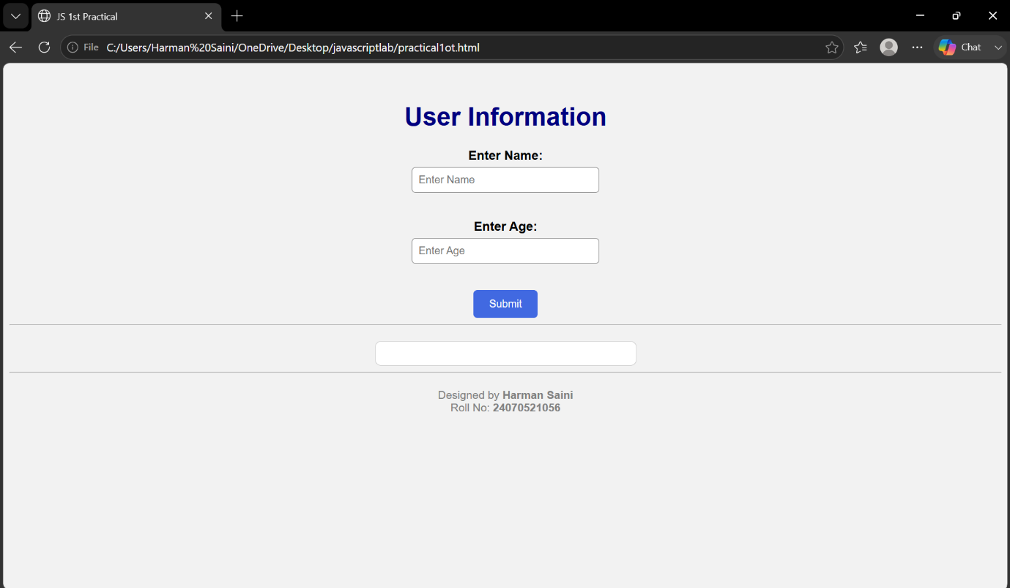
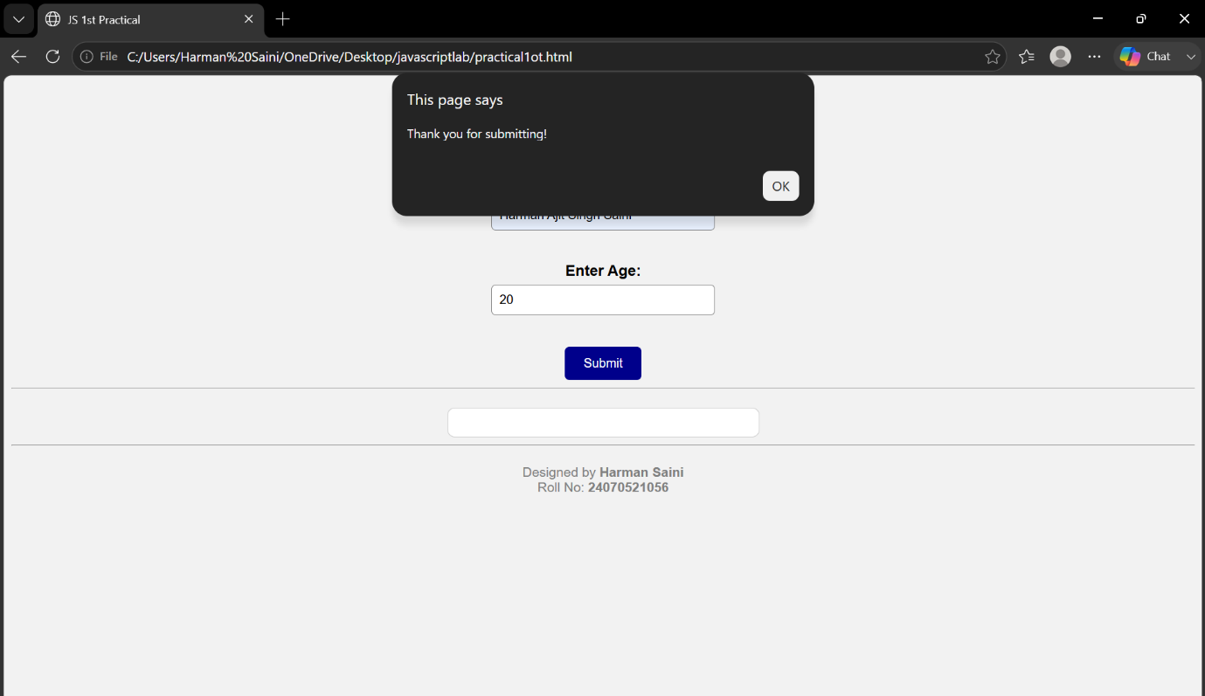
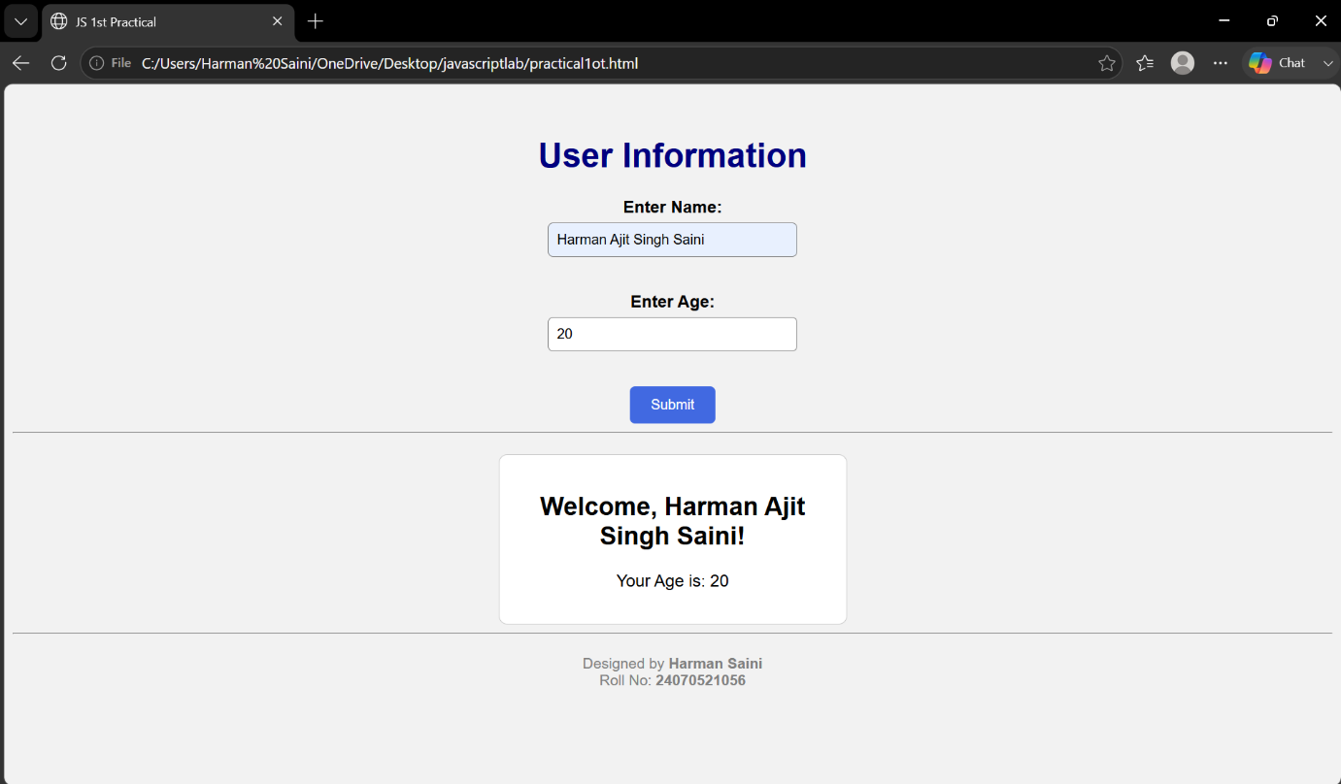

Result/ Conclusion: Thus a working website has been created using HTML, JS and its UI was styled using CSS.

Harman Saini, Sem5-A, 24070521056

